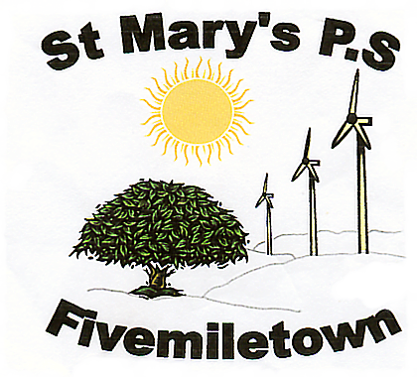

Newsletter- Friday 15th September 2017
Monday- P.5 -7 Library
Tuesday- P.1-4: PE
Irish Class P.5-7
After-school study club for P7 pupils
Wednesday- Library for P.1-4
Swimming P.5-7
Thursday- P.5-7: PE with GAA coach
Red and Green Day
Friday-
P.1-4 Library
P.1-4 PE with coach

Roald Dahl Day
We had a great morning on Tuesday celebrating Roald Dahl day. The weather was very kind to us and we had a lovely walk to the library where we were treated to storytelling and online activities all based upon Roald Dahl. Photos can be viewed on our website. The library is a fantastic facility and I would encourage anyone who has not already joined to do so – you can get forms from the library or school office.
Curriculum Night
Thank you to all of the parents who attended our curriculum night. This was an important night as the teachers were able to explain what they would be teaching in each class this year, as well as offering useful tips and ideas how best to support your child in their learning.

St Mary’s Primary School
70 Colebrooke Road,
Fivemiletown,
Co. Tyrone.
BT75 0SA

Phone: 028 895 21315
Fax: 028 895 21315
E-mail: sgallagher125@c2kni.net

Irish Tuition
We are delighted to once again receive Irish tuition for P.5 -7 which will begin this Tuesday 19th September. This scheme is funded by the Mid-Ulster Council and so there is no charge for it.
Swimming
We have secured a swimming slot in the Youth Annexe for P.5-7 beginning this Wednesday 20th September. We will be attending 6 sessions before Halloween at a cost of £2.00 per child/per session.
Afterschool Club
One or two parents have expressed an interest in our Afterschool’s Club which we hope to run if we have sufficient numbers to make it viable. If you think you might avail of our Afterschool’s Club could you please let us know.
Primary 1
Primary 1 have settled really well into school life in St. Marys. Next week is a big week for them as they will stay until 1.00pm and will take either school dinner or lunch. School meals cost £2.60 and we ask that dinner money is sent to school each Monday morning with the child’s name and the appropriate days clearly marked on the envelope. Dinner money envelopes are available to buy from the school - £2.50 for 50 envelopes.
Vandalism
On Monday morning there were a lot of smashed bottles lying at the entrance of the school gates. This is a real health and safety concern and I hope it was a ‘one off’ incident. Staff also discovered graffiti written all over our outdoor blackboard. We do not know if the two incidences were connected but if there was a reoccurrence of any of these we will have to report these to the relevant authorities.
Red and Green Day
On Sunday 24th September Tyrone Ladies will contest the All Ireland Intermediate Final against Tipperary and Fermanagh Ladies will contest the All Ireland Junior Final against Derry. This is a truly unique and historic occasion and one that we would like to show our support for. As we have both Tyrone and Fermanagh supporters in our school we are having a ‘Red and Green Day’ on Thursday 21st September. Every child is encouraged to wear either red or green on that day to show their support for both counties. Children are asked to bring in £1.00.
Baby and Toddler
Our ‘Baby and Toddler’ Group will return on Friday 6th October and will run on 1st and 3rd Friday of each month from 9.30am – 10.30am. Please share this with others.
GAA Coach
Please note that Fergal Mc Cann has changed his coaching day for P5-7 to Thursday morning.
Afterschool Study Club
Please note that the Afterschool study club for P.7. has been changed to Tuesday this week as I have to attend a meeting on Wednesday.

