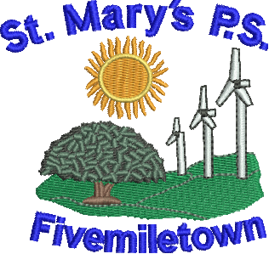

St Mary’s Primary School
70 Colebrooke Road,
Fivemiletown,
Co. Tyrone.
BT75 0SA

Phone: 028 895 21315
Fax: 028 895 21315
E-mail: mmccullagh962@c2kni.net

Newsletter- Monday 8th October 2018

Mon - P1-4 – PE with Oisin McNia
P5-7 Mandarin - 1pm
P5-7 TinWhistle
P7 Study Club – 3.15 to 4.30pm
Tues - P1-4 Central Library
Wed - Cross Country in Ballygawley - 10am
P4-7 Swimming 1.15pm-2pm.
P7 Parent teacher meetings
Thurs - P5-7 Library day.
P1-4 P.E.
Fri - P5-7 – PE with Fergal McCann
P3/4 – Tag Rugby at FMT College.

Parent Teacher Meetings
Parent Teacher meetings for Primary 7 children only will take place this week; Wednesday 10th October from 1pm and each parent has been allocated a time slot to attend. If this date does not suit, could you contact the school to arrange another date or time.

Code Club is cancelled this week as Mrs. Boyd is away on a course on Tuesday. Code club will continue next week but it will be on Wednesday the 17th October from 3.15-4.15pm instead of Tuesday the 16^{th.}

Tag Rugby
Our Primary 3 and 4s will be taking part in a fun tag rugby event on Friday across the road at Fivemiletown College. We wish them well and hope they have a great day.

Shared Education
What a day the children had last Thursday at our ‘Mini Olympics.’ They took part in a range of activities and represented our school brilliantly. Thank you to all those who contributed to the sponsorship for the Northern Ireland Air Ambulance. What a great effort by all. We are still awaiting the total amount raised.

Swimming
The P.4-7 children kicked off their swimming lessons last week and it was a great success. Lessons will continue in the coming weeks at a cost of £2 per lesson.

Table Tennis Exhibition
We had a fantastic morning last Friday when Trevor and Neil came to entertain us with their impressive skills. The children all got to participate and had a great time. The lads spoke to us about the local table tennis club here in Fivemiletown and encouraged all children to attend the local club which takes place on Friday evenings at 6.30pm in the Annex Centre.

Cross Country
We are competing in a cross country event on Wednesday in Ballygawley. All primary 6 and 7 children will be taking part and we will need to randomly select 2 boys from Primary 5 to make up our team. We wish them well!

P1-4 Children
A quick reminder that children in P1-4 are asked to bring in ‘wellie boots’ to leave in school all the time to assist with outdoor play.

Coats
Coming into the colder months we would recommend all children wear coats to and from school. It would also be advisable to clearly mark your child’s name on their coat and all other items of clothing.

Pupil of the week:
P1-4 – Adam Phair
P5-7 – Dara Stewart

Pupil of the Month Awards
P1-4 – Leland McCartan
P5-7 – Aoife Cullinan

Well done guys!

