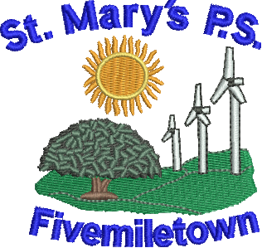

St Mary’s Primary School
70 Colebrooke Road,
Fivemiletown,
Co. Tyrone.
BT75 0SA

Phone: 028 895 21315
Fax: 028 895 21315
E-mail: mmccullagh962@c2kni.net

Newsletter- Tuesday 2nd October 2018

Tues - Code Club P5-7 from 3.15-4.15pm
Wed - P.5-7 Molly and Mia Gardening
P.4-7 Swimming 1.15pm-2pm.
P.7. Study Club – 3.15 to 4.30pm
Thurs - Shared Ed. – Mini Olympics day.
Library day.
Fri - Table Tennis exhibition – 9.30am
P5-7 – PE with Fergal McCann

Parent Teacher Meetings
Parent Teacher meetings for Primary 7 children only will take place next week; Wednesday 10th October from 1pm and each parent will be allocated a time slot to attend. If this date does not suit, could you contact the school to arrange another date or time.

For all other classes, parents will meet with teachers on Friday 23rd November.

After school ‘Code Club’ starts this week with Mrs. Boyd for P.4-7 children and all are welcome. Cost is £2 per session and this will run for 5 weeks. Class will end at 4.15pm.

Healthy Lunch Boxes
We had a wonderful week of activities last week and spoke in depth about keeping our bodies and minds healthy. The children were absolutely brilliant. We would encourage all families to build on this great start to the year and ask that you make a special effort to ensure the children have a ‘healthy lunch box’ to school every day they have lunch. One treat is allowed on a Friday. We appreciate your support with this effort.

Primary 1s staying to 2pm.
The Primary 1 children have settled in amazingly well into life in St. Mary’s and will now stay in school very day until 2pm.

Mathletics
The children all have their Mathletics log in details and can log in to it in school and at home. We ask that you make an opportunity for them to use this at home at least twice weekly. It is an excellent way for them to practise their Maths skills in a fun way.

Shared Education
We are very excited about our ‘Mini Olympics Day’ which will take place on Thursday. Children will need to bring in their PE gear. Warm clothes are advisable.

Molly and Mia
P.5-7 children will be once again taking part in the Community Garden Project with the Molly and Mia Foundation on Wednesday mornings. If children have wellies and gloves it would be great if they could bring them along. Not necessary though – only if they have them.

Swimming
We are delighted to announce that swimming classes for the year will commence this week for P.4-7 children on Wednesdays at 1.15pm. Could you ensure that all permission slips are returned to school as soon as possible. The cost of lessons is £2 per session.

Table Tennis Exhibition
We are having a table tennis exhibition in the hall on Friday morning to help promote this wonderful, fun activity that all children can enjoy and benefit from. It should be fun!

